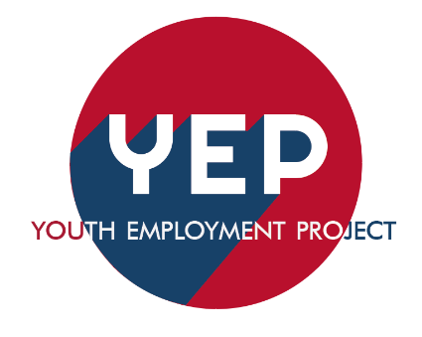
Youth Employment Project
Employer Tool Kit
Meeting Outline for setting up internships

- What type of work would you like the intern to assist with?
(Specific department or task)
Each internship should be built to address needs of the business while providing students a chance to observe the more detailed aspect of work.

- What kind of internship would fit for the work the business is needing done?

- Ongoing daily projects within one department within the business; this is focused more on the tasks rather than shadowing, or a programmatic internship.
- Examples: daily admin assistance, social media assistance, event logistic, data entry, meeting support, customer support, data collection, Research collection.
- These internships can be built and run over several summers as long as the need of the business remain the same and the scoop of work fits the Job Descriptions.
- Specific short-term projects: These Internships may only happen once depending on that need, but it’s a great way to start building ideas for ongoing internships
- Digitalizing files, updating a data base, data collection, longer digital media projects, Videography, graphic design, web updates, software/hardware update

- Programmatic: Internships focused on assist different department daily projects while providing a higher level of job shadows part of the time for the internship to develop an understanding of each department.

- Does your business need assistance with an internship job description? YEP has a library of job descriptions that can be tailored to your business.

Job Descriptions already set up: (see website for additional details)

- Admin assistance
- I.T. Support
- Leadership
- Data entry
- Summer programming
- Marketing
- Engineering
- Public works

- How long would your company want support from an intern?
- 2-3 weeks
- 4-6 weeks
- 7-8 weeks
- All of summer
- Until project is completed
- How do you want to source interns?
- YEP promotes business, handles Interviews, provides referrals
- YEP specifically vets and interviews before business
- YEP vets and places student, business does not have to interview
- Would you like YEP to provide weekly to bi-weekly check-ins on the students to gather reflections?
- Yes, please.
- No, I will provide weekly or bi-weekly touch bases to reflect on the week (or weeks.)
- Can your business provide a mid-point evaluation and a Final Evaluation for the interns?
- Depending on length of internship it could be Bi-weekly touch bases and a single final evaluation.
- If it is a longer-term internship (whole length of summer) we request both to keep the intern in the look of feedback.

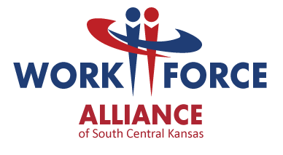
How can employers hire a young adult through YEP?
Employers interested in the YEP should contact:
Chelsea Daniel
316-771-6622
cdaniel@workforce-ks.com

For more information on the YEP or the Workforce Alliance, visit www.workforce-ks.com/yep.
Equal Opportunity Employer/Program – Auxiliary aids and services are available upon request to individuals with disabilities. Any individual with a disability may request accommodations by contacting the Workforce Centers at 316-771-6800, TDD: 711 or 1-800-766-3777, or admin@workforce-ks.com

