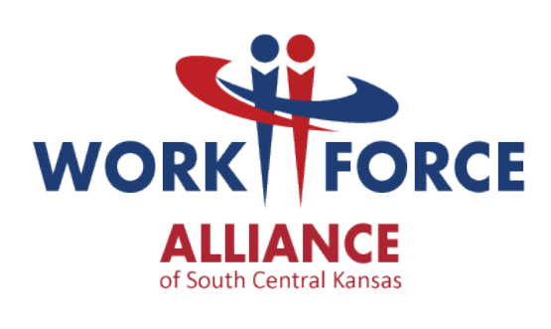

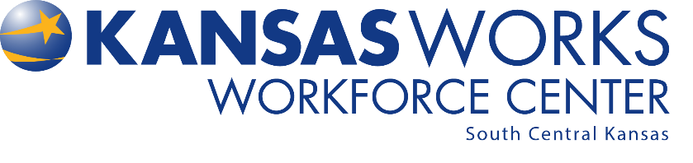

Workforce Centers Handbook

The Workforce Centers are committed to fostering an environment where integrity, leadership, and quality are the basis for all services provided in the Centers to both internal and external customers. The Workforce Centers will create an environment that lends itself to open communication, where all partners understand the importance of complying with policies and procedures and demonstrating ethical behavior in all that we do.

Table of Contents

SECTION I – SAFETY Page 3
  - Emergency Procedures
  - Emergency Non- Evacuation Plan
  - Emergency Evacuation Plan
  - Centers’ Terrorism Emergency Plan
  - Security
  - Personnel Identification
  - Proximity Cards
  - Customer Incidents

SECTION II – PROFESSIONAL CONDUCT Page 16
  - Personal Appearance
  - Sexual Harassment
  - Dealing with the Media
  - Social Media
  - Workforce Center Branding and Outreach Material
  - Outreach Events

SECTION III – FACILITY MANAGEMENT Page 21
  - Hours of Operation
  - Exceptions to Hours of Operation
  - Holidays
  - State Recognized Holidays
  - Absence from Work Assignment
  - Parking
  - Facility Usage
  - Facility Equipment
  - Smoking
  - Cell Phone and Electronic Devices Usage
  - Meeting Room Scheduling
  - Calendars
  - Building Maintenance
  - Definitions
  - Partner Referrals

SECTION IV – CUSTOMER RELATIONS Page 29
  - Equal Opportunity
  - Grievance and Complaint Policy (Attachment F to the MOU)
  - Reporting Suspected Program Fraud or Abuse
  - Limited English Proficiency

SECTION V – CONTINUOUS IMPROVEMENT Page 38
  - Core Values of Performance Excellence
  - Customer Service

SECTION I – SAFETY

- Emergency Procedures

In the event of an emergency or evacuation situation, every employee is responsible for ensuring their own safety. Each partner agency is responsible for notifying its employees, customers, and/or students of an emergency; it is recommended that each partner agency designate notification responsibility.

Depending on the emergency, people may need to evacuate or move to a different location. Everyone needs to be familiar with emergency and evacuation procedures. The Emergency Evacuation Plan applies to any situation in which evacuating is necessary.

Senior management for the Workforce Centers (WFC) have established Emergency Coordinators who are responsible for ensuring everyone is accounted for in case of an emergency or evacuation; their primary responsibility is to notify emergency responders of employees/customers/students unaccounted for. Emergency Coordinators will be coordinating directions and information with WFC Senior Management.

Emergency Coordinators for each Center are as follows (as of July 2018):
- Wichita Workforce Center – George Marko, Erica Ramos, Tisha Cannizzo
- Garvey Center Administrative Office- Denise Houston, Chad Pettera, and Amanda Duncan
- Butler Workforce Center – George Marko
- Sumner Workforce Center – George Marko

Employees should notify their supervisor and/or Emergency Coordinator if their work schedule changes or will be outside of normal office hours. This will ensure that all employees may be accounted for in case of an emergency.

In the event of an emergency that would result in individuals not returning to the office please call the Workforce Center Information line at 316-771-6677

- Emergency Non-Evacuation Plan (Tornado)

In the event of a tornado, all employees shall evacuate to the below identified designated safety area:
- Wichita Workforce Center –The Jabara room and restrooms on the north side of the building (near the Keeper of the Plains room) should be filled first, then overflow into the Eisenhower and McConnell rooms
- Garvey Center Administrative Offices- Interior space away from windows or the basement of either of the facilities
- Butler Workforce Center – South Central Mental Health has a designated shelter on the south side of the building
- Sumner Workforce Center – the interior restroom

Once in the designated safety area, persons shall:
- Stay away from all glass windows and doorways
- Remain in the safety area until given the all clear from Emergency Coordinators

Employees and/or customers with disabilities should discuss what to do in case of a tornado with their supervisor and Emergency Coordinator.

Tornado drills will be held annually each spring.

- Emergency Evacuation Plan (Fire or Other Emergency Warranting Evacuation)

A fire route diagram is located in each Center. Each diagram details the location of fire alarm pulls if applicable, fire extinguishers, and fire exits. Center employees should be familiar with the locations of fire alarm pulls if applicable, fire extinguishers, and fire exits.

If a Center employee smells smoke or sees fire, the employee shall locate the nearest fire alarm pull if applicable, activate the pull, and evacuate the building. If a fire alarm pull is not available evacuate and call 911.

Employees and customers will be notified to evacuate by:
- An audible alarm for fire
- A verbal announcement made by Emergency Coordinators for other emergencies

In the event of fire or other emergency warranting evacuation, ALL employees and customers shall:
- Evacuate immediately by means of the nearest available marked exit
- Use the stairs; do not use the elevators
- Avoid any delay in evacuation for the purpose of critical operations shutdown procedures; no employee is authorized to delay evacuation for this purpose

In the event of an emergency, all employees shall evacuate to the below identified designated evacuation area:

- Wichita Workforce Center – in the parking lot north of Walmart
- Garvey Center Administrative Office- in front of the Chamber of Commerce (East of Garvey Center at Douglas and Waco)
- Butler Workforce Center –in the parking lot near Main Street
- Sumner Workforce Center – directly across Washington Street

Employees and/or customers with disabilities should discuss what to do in case of an evacuation with their supervisor and Emergency Coordinator.

Each partner agency shall account for their personnel, clients, visitors and/or students once they reach the designated evacuation area. A representative of each agency will then contact the Center’s Emergency Coordinators or leave a message on the Workforce Information phone line 316-771-6677 to report that everyone with the partner agency is accounted for.

No employee will be required or assigned to perform medical or rescue duties during emergency evacuation situations.

Fire drills will be held at least once a year.

- Centers’ Terrorism Emergency Plan

Active Shooter or Violent Person
In a situation where there is a violent person with a weapon, quickly determine the most reasonable way to protect your own life. Remember that customers are likely to follow the lead of employees and managers during a dangerous event.

Taken from guidance provided by the Department of Homeland Security:

    - Evacuate
If there is an accessible escape path attempt to evacuate the premises. Be sure to:
- Have an escape route and plan in mind
- Evacuate regardless of whether others agree to follow
- Leave your belongings behind
- Help others escape, if possible
- Prevent individuals from entering an area where the active shooter may be
- Keep your hands visible
- Follow instructions of any police officers
- Do not attempt to move wounded people
- Call 911 when you are safe

    - Hide out
If evacuation is not possible, find a place to hide where the active shooter is less likely to find you.

Your hiding place should:
- Be out of the active shooter’s view
- Provide protection if shots are fired in your direction (i.e. an office with a closed and locked door)
- Not trap you or restrict your options for movement

To prevent an active shooter/violent person from entering your hiding place
- Lock the door
- Blockade the door with heavy furniture

How to respond when Law Enforcement arrives:
Law enforcement’s purpose is to stop the active shooter/violent person as soon as possible. Officers will proceed directly to the area in which the last shots were heard.
- Officers usually arrive in teams of four
- Officers may wear regular patrol uniforms or external bulletproof vest, helmets, or other tactical equipment
- Officers may be armed with rifles, shotguns, handguns
- Officers may use pepper spray to tear gas to control the situation
- Officers may shout commands, and may push individuals to the ground for their safety

How to react when law enforcement arrives:
- Remain calm and follow officers’ instructions
- Put down any items in your hands (i.e. bags, jackets)
- Immediately raise hands and spread fingers
- Keep hands visible at all times
- Avoid making quick movements towards officers such as attempting to hold on to them for safety
- Avoid pointing, screaming and/or yelling
- Do not stop to ask officers for help of directions when evacuating, just proceed in the direction from which officers are entering the premises

Information to provide to law enforcement or 911 operators:
- Location of the active shooter
- Number of shooters. If more than one
- Physical description of shooter/s
- Number and type of weapons held by the shooter/s
- Number of potential victims at the location

The first officers to arrive to the scene will not stop to help injured persons. Expect rescue teams comprised of additional officers and emergency medical personnel to follow the initial officers. These rescue teams will treat and remove any injured persons. They may also call upon able-bodied individuals to assist in removing the wounded from the premises.

Once you have reached a safe location or an assembly point you will likely be held in that area by law enforcement until the situation is under control and all witnesses have been identified and questioned. Do not leave the safe location or assembly point until law enforcement authorities have instructed you to do so.

Along with the guidance above from the Department of Homeland Security and training provided by the Sedgwick County Sheriff Department we encourage all staff partners to Run (Evacuate), Hide, and Fight (as a last resort).

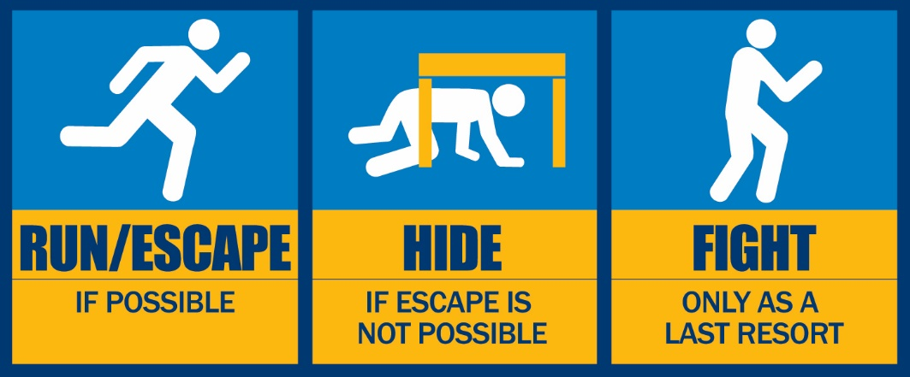

If you become a hostage do what is in the best interest of you, customers, and other employees to become in a position to Run, Hide, or Fight; this may be to obey commands and instructions until it is safe to evacuate.

All Workforce Center locations will have independent plans established and posted on the Workforce Centers intranet and printed materials placed in secure locations in each office building. The plans will include exits, assembly points, and information on making contact with the administrative office. Staff members need to make themselves familiar with the information should an event occur and the plans need to followed.

In all evacuation situations the Workforce Centers Information Phone Line, 316-771-6677 will be a source of information for staff members and partners.

Bomb Threats
Bomb threats may be made in a variety of ways. The majority of threats are received through phone calls, but can be communicated in person, in writing, or by a recording. Information you collect is vital in helping authorities in the investigation. Make sure you have access to the Workforce Center Bomb Threat Checklist form; keep a blank copy near your phone. If you receive a threat or see a suspicious device or package, call 911.

A sample of the Workforce Center Bomb Threat Checklist form may be found below. An electronic version of the form will be made available to all partner agencies. Additionally, a printable PDF version of the form may be accessed through the Workforce Alliance website by following the steps below:

- Go to www.workforce-ks.com
- Login in to the Intranet
- Use the search icon (magnifying glass) to open the search bar
- Type in “Bomb Threat Checklist” and hit Enter
- Click on link to open the Word document

We recommend that you print this document and keep it near your phone. If it is not available, and there is not time to access the form, please write down as much as possible in detail to share with law enforcement and Emergency Coordinators.
Bomb Threat Checklist – Sample Form, Page 1 of 2
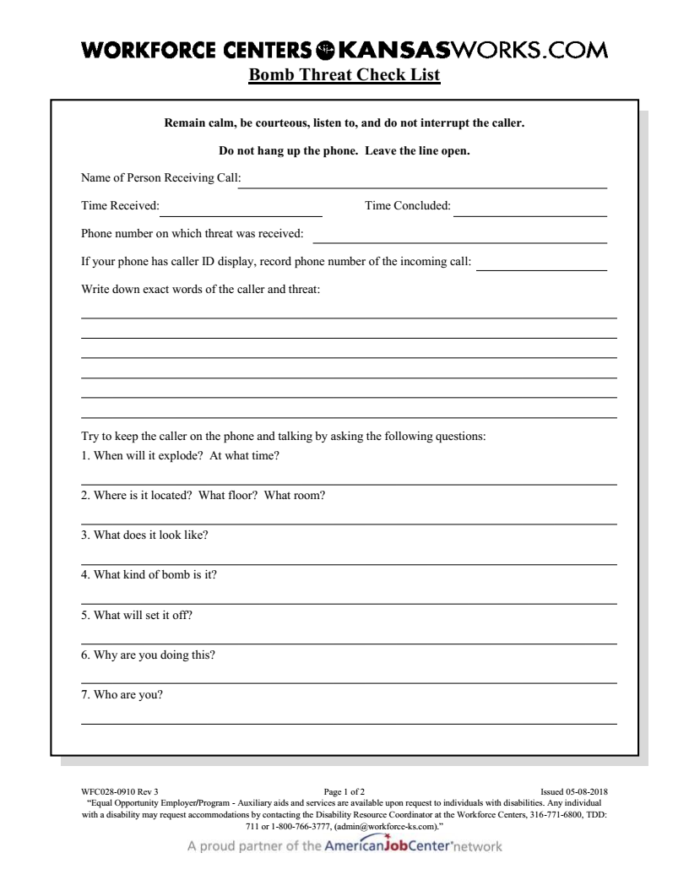

Bomb Threat Checklist – Sample Form, Page 2 of 2
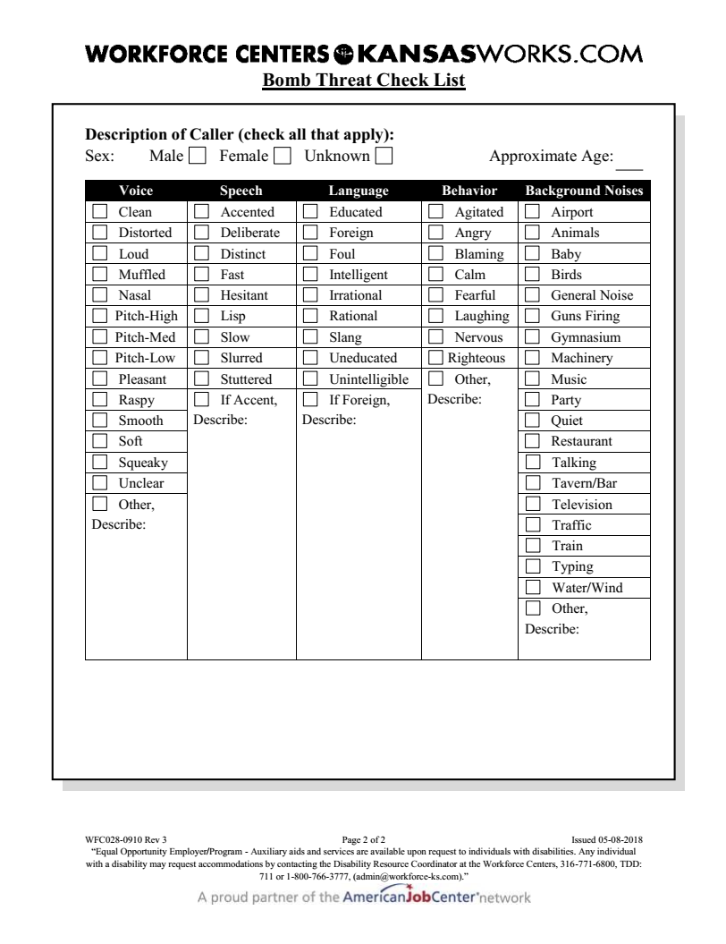

Handling Suspicious Letters or Packages
Employees should not open, shake, empty or otherwise disturb a suspicious package/letter or its contents. Put the package down and do not handle it further. Do not touch or try to clean up any substances from the package/letter. Employees should remove any items from the area of the suspicious package/letter. Alert others nearby, security, 911, and evacuate the area. After leaving the area, employees should wash their hands well with soap and water and limit movements within the building to prevent the spread of any substances.

Characteristics of suspicious packages/letters include the following:
- Mailing Address – Incorrect titles, titles without names, no return address, postmark does not match return address, distorted handwriting, block printing, misspelled common words, restrictive markings such as confidential or personal, foreign mail, airmail and special delivery
- Packing – Oily stains and discoloration, crystals, powder, or powder-like residue, excessive weight, rigid envelope, uneven envelope, protruding wires or aluminum foil, strange noise or odor, excessive postage, suspicious or threatening language, and excessive tape or string

- Security

Wichita Workforce Center
Security guards are on site during regular office hours and are responsible for opening and securing the Wichita Workforce Center. Security may be contacted by calling *01 from any phone in the building. Security guards are not armed, nor are they law enforcement. Security guards should not be used in place of law enforcement. If an employee requires the assistance of law enforcement, the employee should contact 911.

Butler Workforce Center
Security guards are not on-site. If an employee requires the assistance of law enforcement, the employee should contact 911.

Sumner Workforce Center
Security guards are not on-site. If an employee requires the assistance of law enforcement, the employee should contact 911.
- Personnel Identification

Photo ID badges and engraved magnetic name tags are provided to employees at the Centers. As a safety measure, employees are required to wear either their ID badges or engraved magnetic nametag during working hours or any time the employee is representing the Workforce Centers. For replacements of ID badges contact the Workforce Alliance Office Manager, Michelle Schintgen, at 316-771-6650. Contact your supervisor for a new or replacement engraved magnetic nametag.

- Proximity Cards and Keys

A Proximity cards, also known as a “prox card” provides access and security to a location by using an embedded metallic antenna that stores cardholder information. The Workforce Centers use prox cards to control access to several buildings, records areas and to print to the Network Copy Machines.

All employees and partners will be issued a prox card by the Workforce Alliance (WA) IT Department.
Prox Cards are to be used only by the authorized employee or partner, they are not transferable and any unauthorized use by anyone other than the employee or partner, whom the card has been issued, is grounds for confiscation of the card.

A lost or stolen Prox Card must be reported immediately to your supervisor (if applicable), either in person or via email, and to the WA IT Department via email at helpdesk@workforce-ks.com. Normal daily use of a prox card has a lifespan of 2 plus years from the time of issue. If you lose or damage your card within 2 years, it will be replaced as described below and your 2-year cycle will start over from your replacement date.

- The first time a card is lost or damaged the replacement is free.
- The second (or subsequent) time a card is lost or damaged there will be a $10.00 replacement fee, cash only, payable when new card is received.
- Damaged cards will be replaced in person, and brought to the WA IT Department, before a replacement card can be issued.
- Worn out cards, more than 2 years old, may be replaced without charge.
- If a card malfunctions, and is not damaged, bring the card in person to the WA IT Department, staff will determine the cause of the malfunction, and will fix or replace as needed.
Please take the following into consideration:
- Do not use the card for any other purpose other than for access control.
- Do not leave it in direct sunlight, for example on the dash of a car.
- Do not expose it to extreme heat or open flame, for example clothes washers, dryers or irons.
- Do not expose it to organic solvents, thinners, mineral spirits, etc.
- Do not use it as an ice scraper or scraping tool.
- Do not crimp, bend, or twist the card
- Do not machine wash or submerge in water

Partners may be issued keys to the facility at the discretion of the Workforce Alliance. Partners will sign for keys and are expected to safeguard them against loss or theft. Keys are not to be given to other partners, customers, family members, visitors, etc. Lost or stolen keys are to be reported immediately to the Workforce Alliance.

- Customer Incidents

Behavior Based Incident
If staff sees or hears inappropriate behavior and/or behavior unrelated to job searching, staff should address the issue with the customer. If the behavior continues, staff should ask another staff member to address the issue with the customer. If the customer is still not compliant, staff shall locate a supervisor to address the issue with the customer. It is up to the discretion of the supervisor to determine if an WFC029-0910 Incident Report is to be completed based on the customer’s behavior or pattern of behavior. Supervisors will direct staff to fill out an Incident Report if one is warranted. If the supervisor determines an Incident Report is not needed, a Job Seeker Note should be entered in KANSASWORKS documenting the customer’s behavior and noting that the supervisor opted not to complete an Incident Report.

Injury/Accident/EMS
If an injury or accident occurs, staff should first call 911 if medical assistance is needed. Staff should then locate a supervisor. Supervisors are responsible further handling of the situation and informing the appropriate Director. An Incident Report shall be completed in this situation.

Threatening Behavior/Police
If a customer is acting in a way in which police assistance is needed, staff should first call 911. Situations in which police assistance is needed include but are not limited to: physical altercations, weapons, and actual destruction of property. Then staff should call security and locate a supervisor. Security can be reached by phone by dialing *01 or on MiCollab (Security Officer). Supervisors are responsible for further handling the situation and informing the appropriate Director. An Incident Report shall be completed in this situation.

Completing the WFC029-0910 Incident Report Form
Incident Reports are to be completed and submitted through M-Files within 24 hours of the incident. Involved staff should begin the incident report then send to the supervisor who responded to the incident. The supervisor must sign off on the report and submit it through M-Files.

When creating a new incident report, the document should be named according to the following convention: Customer’s First Initial Customer’s Last Name Incident Report Date (year, month, day) (JSmith Incident Report 20190418). If the customer’s name is unknown, staff should enter Jane/John Doe with four zeros as the participant ID.

When uploading the document, use the “Incident Report” class of document found under “Customer Incident” and complete the additional required information. The “Incident Report” workflow should then be chosen; this will assign the report to all senior leadership to be approved or returned for corrections. All supervisors will also receive a notification when the workflow is started.

Customer Restrictions
At times, based on behavior or a pattern of behavior, customers may be banned from the Center or have restrictions placed on future visits to the Center. In these situations, customers are notified via letter of their restrictions; customers cannot be banned immediately following an incident. Senior management will be involved in any decision regarding banning customers.

While in WaitWhile, staff are able to see the “Black Flagged” notation on a customer’s account.

If a customer has already been served and left the facility, flagged notes may still be added to the customer’s account. Staff should also be aware that when booking or checking in a walk-in customer, a flag may appear on an account that is not actually associated with that customer. Because WaitWhile uses similar data (phone numbers, participant IDs, etc.) to retrieve repeat customer information, it is possible that a new customer might have a phone number that was previously associated to a flagged customer. For this reason, Jobseeker Notes must always be consulted in KANSASWORKS to verify a flag and to discover the reason for the flag.

Speaking with Customer
If a customer is flagged during the check in process, do not tell the customer. Instead, let the customer know that there is an issue with the check in system, and that a supervisor is needed; ask them to have a seat while the issue is resolved.

Center Incident Report – Sample Form, Page 1 of 2
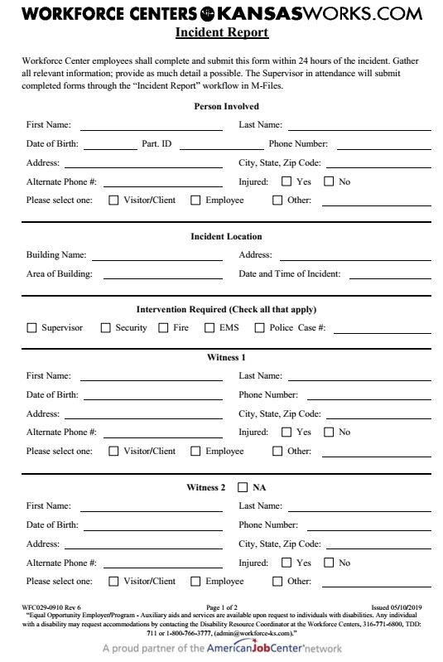

Center Incident Report – Sample Form, Page 2 of 2
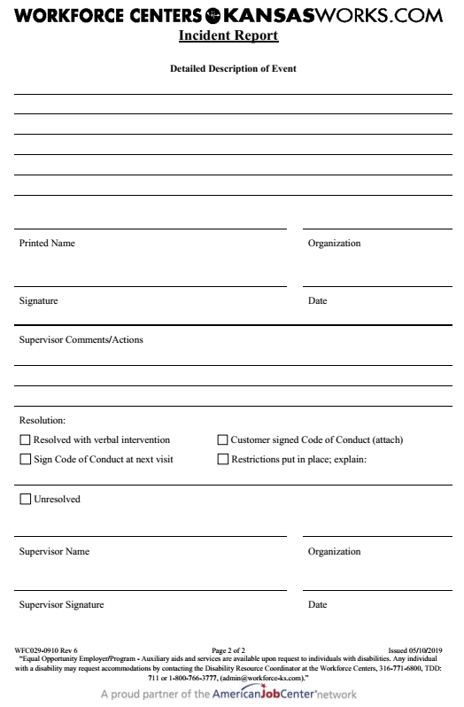

SECTION II – PROFESSIONAL CONDUCT

- Personal Appearance

The appearance of employees at work influences the public’s perception of the Workforce Centers’ competence and professionalism. The Workforce Centers of South Central Kansas rely on employees to present a positive, professional, business-like image to internal and external customers through dress and personal appearance for their position.

It is important to remember that clothing, body art/tattoos, piercings, hair color, and other grooming techniques that impair performance or disrupt the transaction of public business are not permitted. Below is guidance on personal appearance; please note that supervisors and senior management may use their discretion for specific events or occasions, when appropriate. Employees should consult their supervisors or HR if they have questions as to what constitutes appropriate appearance for their position.

Guidance
To facilitate customer service and safety, everyone working in the Centers is given an ID badge and an engraved name tag. A name tag or ID badge shall be worn at all times including networking events or other off-site events where the employee is representing the Workforce Centers.
- Name tags and ID badges should not be modified in any way
- ID badges may be worn on decorative lanyards as long as they present a professional image

The Workforce Centers of South Central Kansas has adopted a Dress for Your Day approach to workplace attire. The Dress for Your Day (DFYD) policy encourages personal discretion by allowing staff to determine their clothing choices based upon the day-to-day demands of their role and the work they perform. DFYD work attire is intended to be more casual or relaxed when employees have a workday that does NOT include external meetings with partners and vendors. Customers are not considered the same as external meetings, therefore, DFYD approved attire would be appropriate. The expectation is that employees will wear professional clothing appropriate for the nature of the business and the type of work performed. If you have questions you should refer to your supervisor or HR before the day of the event.
To provide staff guidance and explanation, some minimum dress standards are below:
- Attire should be clean, neat, and appropriate to the workday
- Attire should not be offensive or disruptive to others
- Staff are expected to practice good personal hygiene
- Facial hair must be neat and trimmed
- If an employee is not sure their clothing meets the dress code, they should consult with their supervisor or HR

Attire | DFYD Approved | Inappropriate at any time
Pants/Skirts/  Dresses | - Dress pants  - Dresses  - Khakis  - Capris  - Skirts of appropriate length that come to the top of the knee  - Professional jeans/denim (clean, free of rips, tears, and fraying and not tight or revealing)  - Leggings are permitted only when worn in the same manner as hosiery | - Sweatpants  - Pajamas/loungewear  - Exercise apparel or activewear  - Beachwear  - Shorts  - Ripped pants of any kind  - Short skirts  - Leggings, unless paired with appropriate length skirt or dress  - Garments that are dirty, wrinkled, ripped or faded  - Stirrup pants and other pants that fit like hosiery do not project a professional image and are not permitted
Shirts/Tops/  Jackets | - Sport coats or suit jackets  - Dress shirts  - Ties with dress shirts  - Polo collar knit or golf shirts (small logos okay on chest or sleeves otherwise no large logos)  - Button down shirts  - Professional blouses with sleeves, or sleeveless but covered by a suit jacket if they don’t cover the shoulder  - Sweaters, long and short sleeve  - Knit professional shirts  - Turtlenecks  - Sleeveless professional tops are allowed as long as they are professional and cover the entire top of shoulder | - No graphic shirts  - No team wear with excessive graphics unless specified for the day  - Shirts with offensive writing or large logos  - T-shirts or sweatshirts  - Beachwear, tank tops  - Exercise apparel or activewear  - Crop tops, clothing showing midriffs, halter tops  - Garments that are dirty, wrinkled, ripped or faded  - Under garments should not be visible
Shoes | - Loafers or tie shoes  - Dress shoes, pumps, Dress boots  - Dress sandals  - Deck shoes  - Clean cowboy boots  - Casual, open-back shoes (mules, sling backs)  - Flats –not house shoes or slippers  - Athletic or walking shoes – they must be clean and only used for work activities | - Beach flip flops or floppy sandals  - Slippers  - Dirty shoes  - No gym shoes or specific sport shoes  - Combat boots  - Work boots  - Crocs
There will be times when specific attire may be requested by senior management based on business needs or special occasions. On those occasions, special DFYD requirements will be announced by senior leadership. The following categories of dress may be announced:

Business Casual dress guidelines:
Tops
- Button down and polo-style shirts are appropriate
- Sleeveless tops are permitted, as long as they are professional in style and the entire top of the shoulder is covered
- Shirts that have sheer or lace material on the shoulders are permitted; sheer or lace material should not extend to the middle of the back where undergarments may be exposed
- Tops and dresses should cover the entire top of the shoulder, back, and midriff

Bottoms
- Dress pants and khakis may be worn, but hems must be below the knee (full-length, ankle-length/cropped, or Capris) and should be professional and in good condition; styles that are extremely casual, faded, frayed, wrinkled, or worn are not permitted
- Skirts and dresses are appropriate and should be of proper length and style for the business environment: no shorter than the top of the knee when standing
- Denim and jean-like material are not appropriate for business casual dress
- Stirrup pants, leggings, and other pants that fit like hosiery do not project a professional image and are not permitted

Hosiery, Foot Coverings, Misc.
- Leggings are permitted only when worn in the same manner as hosiery
- Sandals and other open-toed shoes must have a discernable heel; foam-soled footwear is not permitted
- Flip flops or beach/pool sandals are not permitted
- Flats are permitted, but they should not resemble house shoes or slippers
- Combat, and work boots are not permitted; Cowboy boots may be worn, but they must be clean and in good condition
- Tennis shoes and sport shoes are not permitted
- Hairstyles should be well-groomed and clean
- Facial hair must be neat and closely trimmed

Business Professional dress guidelines:
- Suits (skirt or pants) with coordinating shirt and tie are preferred
- Dresses and dress skirts or slacks with coordinating shirt, sweater, jacket, vest, or blazer are also appropriate
- Skirts should be of proper length for the business environment: no shorter than the top of the knee while standing
- Denim or jean-like material does not reflect a professional image and is not considered appropriate
- Dress shoes and dress boots are appropriate footwear

Accessories should be professional and not to excess. Head coverings, including scarves (not worn as bandana), are permitted as long as they complement the other clothing items and present a professional image. Outdoor hats do no present a professional image and are not permitted.

Visible tattoos are permitted with the exception of tattoos that display words or images of violence, hate, gore, blood, obscene language, or that may violate a staff member or customer’s equal opportunity protections under the law.

Ear, nose, and lip piercings are permitted. Nose piercings may include small studs, rings, or culturally significant jewelry. Lip piercings should be discreet and not pose safety hazards. Employees are encouraged to express themselves through jewelry and accessories that do not compromise safety or professionalism. While we encourage individual expression, we ask employees to be mindful of safety, hygiene, and the potential for distraction. Examples of piercings that are not allowed: Piercings that are large or elaborate, such as spikes or gauged piercings. Piercings that are offensive or obscene in nature.
Religious and/or physical accommodations to this policy may be made. In order to request an accommodation, please contact your local HR.

- Sexual Harassment

To ensure a work environment free of sexual harassment, each partner agency providing services within the Workforce Center is expected to have a sexual harassment policy and to clearly communicate the policy to personnel working in the center. Employees should follow the reporting requirements of their organization

In addition to sexual harassment of co-workers, as described in each partner agency’s policy, sexual harassment of employees of partner agencies and of customers is prohibited.

C. Dealing with the Media

No Workforce Center staff or partner shall communicate with the media except for the VP/Chief Business Development Officer (Amanda Duncan) or the President/Chief Executive Officer (Keith Lawing) of the Workforce Alliance unless given prior approval by the President/Chief Executive Officer of the Workforce Alliance. If the media comes to a Workforce Center, there are business cards for the VP/Chief Business Development Officer and President/Chief Executive Officer at the Information Desk. If the media calls, the call should be transferred to the President/Chief Executive Officer. If the media emails, the email should be forwarded to the President/Chief Executive Officer.

D. Social Media

What Social Media means to us:

Conversations take place online about the Workforce Centers every day, and we want our staff to join those conversations, represent the Workforce Centers, and share the optimistic and positive spirits of our brand.
These Social Media Principles should guide your participation in social media, both personally as well as when you are acting in an official capacity on behalf of the Workforce Centers. The same considerations that apply to our messaging and communications in traditional media still apply in the online social media space, including on what you might consider “internal” platforms.

Have fun, but be smart. Use sound judgment and common sense, adhere to the Workforce Centers values, and follow the same Workforce Centers policies that you follow in the offline world. To get you started or to help you improve your social media skills, we offer training to our associates and our agency partners, and we’ll continue to regularly evaluate our training classes and update them as social media evolves.

Workforce Centers Commitment:

The Workforce Centers makes certain commitments concerning how we interact with the public and each other, and these commitments apply to interactions that occur on social media platforms as well. We expect the same commitments from all Workforce Centers staff and partners.

- Workforce Centers will be transparent in every social media engagement.
- Workforce Centers will protect our customers’ privacy in compliance with applicable Privacy Policies, IT Security Policies, and laws, rules, and regulations.
- Workforce Centers will respect copyrights, trademarks, rights of publicity, and other third-party rights.
- Workforce Centers will be responsible in our use of technology and will not knowingly align our Workforce Centers with any organizations or Web sites that use excessive tracking software, adware, malware or spyware.

Workforce Centers will reasonably monitor our behavior in the social media space, establish appropriate protocols for establishing our social media presence, and keep appropriate records of our participation as dictated by law and/or industry best practices.

Workforce Centers and agency associate social media activities:

The Workforce Centers respects the rights of its associates and partner associates to use blogs and other social media tools not only as a form of self-expression, but also as a means to further the Workforce Centers’ business. It is important our associates and our partners are aware of the implications of engaging in social media and online conversations that reference the Workforce Centers, its brand, or its business, and that they recognize when the Workforce Centers might be held responsible for their behavior. Our expectations for personal and professional/official use of social media are set forth separately below.
Personal use of Social Media: Expectations

Whether you are an authorized Workforce Centers spokesperson or not, when you’re talking about the Workforce Centers, our brand, or our business on your personal social networks, keep in mind that:

The Workforce Centers’ Information Technology Policy and other policies still apply.
- You are responsible for your actions. We encourage you to get online and have fun, but use sound judgment and common sense.
- You are an important ambassador for the Workforce Centers’ brand, and you are encouraged to promote it as long as you make sure you disclose that you are affiliated with the Workforce Centers. How you disclose can depend on the platform, but the disclosure should be clear and in proximity to the message itself.
- When you see posts or commentary on topics that require subject matter expertise, such as policies, operations or the Workforce Centers’ financial performance, avoid the temptation to respond to these directly. When in doubt, contact the Vice President/Chief Business Development Officer.
- When in doubt, do not post.
- Give credit where credit is due and do not violate others’ rights. DO NOT claim authorship of something that is not yours. If you are using another party’s content, make certain they are credited for it in your post and they approve of you utilizing their content. Do not use the copyrighted material, trademarks, publicity rights, or other rights of others without the necessary permissions of the rights holder(s).
- Remember the Internet is permanent.

E. Workforce Center Branding and Outreach Material

The Workforce Center strives to have a consistent marketing and branding through all brochures, flyers, forms, handouts, and presentations. Located on the Workforce Center Intranet page, under the “Toolkit” there are various pre-made templates for your use. Outreach material is maintained in each office please see your supervisor for assistance.

For use of Workforce Center Logo’s please contact Jamey Regier. To update or create a form please contact Denise Houston.

F. Outreach Events

Partners that plan to attend Outreach events in the community shall coordinate attendance at such events with George Marko, Director of Integrated Employment Services. Doing so ensures that there is no duplication of outreach efforts in the community.
SECTION III – FACILITY MANAGEMENT

- Hours of Operation

General operating hours for the Workforce Centers are as follows. Please note operating hours may change due to unforeseen circumstances. Staff and partners will be notified of any changes as soon as possible.

CENTER | HOURS
Butler Workforce Center | In-person & Virtual Services  Monday—Thursday  8:00am—5:00pm  Friday (virtual services only)  9:00am—Noon
Cowley College Workforce Center | In-Person & Virtual Services  Monday—Friday  8:00am—5:00pm
Harper Workforce Center | No Established Office; Services By Appointment
Kingman Workforce Center | No Established Office; Services By Appointment
Sumner Workforce Center | In-Person & Virtual Services  Monday—Thursday  8:00am—5:00pm  Friday (virtual services only)  9:00am—Noon
Wichita Workforce Center | In-Person & Virtual Services  Monday-Thursday  7:00am—6:00pm  Friday (virtual services only)  9:00am—Noon
Garvey Center Administrative Offices | Monday—Thursday  8:00am—5:00pm  Friday  9:00am—Noon

- Exceptions to Hours of Operation

If there is a reduction in hours of operation, partner agencies and the media will be notified (e. g. inclement weather) by the President/CEO of the Workforce Alliance or his Designee. Workforce Center staff/partners may call the Workforce Centers Information Line at 316-771-6677 to learn of any potential Center closing and/or delay in opening due to inclement weather.

Requests for an increase in hours of operation may be made to the Workforce Alliance.
- Holidays

The Workforce Centers will be closed on holidays observed by the State of Kansas. However, partner personnel may observe their employer’s holiday schedule.

- State Recognized Holidays

New Year’s Day Labor Day Christmas Day
Martin Luther King Jr. Day Veterans Day
Memorial Day Thanksgiving Day
Independence Day Friday after Thanksgiving

- Absence from Work Assignment

When a partner agency will not be represented at a Center, the agency is asked to notify the other one-stop partners as a courtesy, and to facilitate planning and customer service.

- For scheduled absences, of an entire partner agency, partners are asked to provide ten (10) working days’ notice whenever possible.
- For unscheduled absences of the entire agency, partners are asked to telephone the Operator at 316-771-6600 by 9:00 a.m. of the workday.

- Parking

Administrative Offices
- Parking is available in the parking garage directly behind the R.H. Garvey Building.
- Customers may park in parking spaces designated for visitors.
- A parking voucher will be issued when parking in the garage.
- Vouchers are validated at the front desk of the Administrative Offices on the 8th floor.
- Staff may not park in visitor parking.

Wichita Workforce Center
- Parking is available in the lot located northeast of the building.

Butler Workforce Center
- Parking is available in the lot located west and of the building.

Sumner Workforce Center
- Parking is available along the street east of the building.

- Facility Usage

The Workforce Alliance will make reasonable efforts to provide for the security of partners, property and visitors; however, the Workforce Alliance assumes no responsibility for loss, damage, or theft of personal property.

Staff and partners are not to use air fresheners, potpourri, or fragrance devices of any kind in open or public areas. Only air fresheners or fragrance devices placed by management are allowed in open or public areas. Air fresheners that plug in, warm, heat, or are liquid that do not come with a firmly attached lid are prohibited.

Please do not attach anything to any structure without permission of the Workforce Alliance.

- Meeting Etiquette

The Workforce Centers may host meetings for existing and potential partners that include food and or drinks throughout the year. Staff invited to attend the meeting should wait to get food until all guests have been served. Staff that are not attending the meeting shall not enter meeting rooms to eat unless instructed to by a supervisor.

Any leftovers will be moved to the breakroom where staff at large may help themselves. Leftovers are first come, first served; however, staff should be considerate of others who may have work duties to complete before they are able to eat. No staff should save leftover items to take home until all staff have had a share, and the items are to be disposed of.

Drinks are to be left for the group until meeting participants have left the building. Additionally, reusable items, like bottled drinks, will be saved to be used for future events and should not be consumed by staff.

- Facility Equipment

All repairs and maintenance of equipment belonging to the Center will be conducted by the Workforce Alliance or contracted service provider. Please advise the Workforce Alliance of equipment that is not working properly.

Written authorization from the Workforce Alliance is required prior to removing equipment belonging to the Centers from the facility. Partners are responsible for the proper use, care and return of all property and equipment assigned to them.

- Smoking

To maintain a safe and comfortable working environment and to comply with local ordinances, the Workforce Centers are smoke free facilities. There are designated smoking areas outside of each Center no less than 25 feet from the building.

- Cell Phone and Electronic Devices Usage

In order to be respectful of other staff and customers, Workforce Center staff are to follow the below guidelines regarding cell phone and electronic devices at the Workforce Center. Be mindful of the Local Area IV Customer Service Grid when utilizing devices in the Workforce Centers of South Central Kansas.
- Cell phone or other electronic device ringers should be turned off, changed to mute, or vibrate during work hours.
- Cell phones or other electronic devices should not be left unattended in the Workforce Center. Employees assume the risk of loss or damage to cell phones or electronic devises carried during their workday.
- Personal cell phones calls should be made during break or lunch times to the maximum extent possible. Frequent or lengthy cell phone calls may adversely affect productivity and disturb others.
- To protect the privacy of fellow employees and customers, the use of cameras on cell phones or other electronic devices during work time should be used with the consent of management and of the person(s) present at the time.
- Streaming music is allowed as long as it does not interfere with productivity. Staff is not to use Workforce Center Wi-Fi and must use their own data for streaming. Staff streaming music must use headphones in the open office area.

- Meeting Room Scheduling

Shared meeting rooms may be reserved by contacting the designated scheduler for each facility. The schedulers are responsible for ensuring there is no conflict. When reserving meeting rooms, thirty minutes will generally be included before and after each meeting for preparation and break down. When scheduling a room, please identify the organization using the room, name and telephone of a contact person, the type of event and number expected to attend. Due to limited meeting rooms, it is essential all cancellations be updated on the appropriate system in each Center.

The designated scheduler of meeting rooms for each facility is Kennisha Rolfe.

- Calendars

Partners may view calendars for meeting rooms and other individual partners as abilities and permissions allow.

- Building Maintenance

Janitorial services provide a clean work environment. Janitorial issues should be directed to the Workforce Alliance.

Garvey and Wichita Workforce Center
Janitorial and maintenance services are provided by the Workforce Alliance.

Butler and Sumner Workforce Centers
Maintenance issues should be handled by each office’s lead staff. The lead staff should communicate all issues to the Workforce Alliance.

- Definitions

The Workforce Centers and partners have agreed to use common definitions for terms related to the provision of services and shared funding. Through the use of common definitions, all parties achieve consistency in the provision of similar services to customers. These terms are defined below:

Preliminary Services:
- Public Information: Facts about a Partner’s services distributed to the public.
- Outreach, Recruitment: Information about a Partner’s services circulated to potential customers for the purpose of attracting customers to the program.
- Determination of Program Appropriateness for Customer: A decision about whether the Partner provides services suitable for the customer.
- Orientation: Explanation of the Partner’s services and requirements to customers.
- Resource Center: A library of workforce, career and supportive service information, open to the public. Information may be accessed through a variety of means including electronic and hard copy.
- Initial Assessment: Interviewing and asking questions that would assist customer to consider his/her resources, skills, abilities, and service needs as related to a plan of action.
- Workshops: Short-term instruction to groups of customers to impart knowledge or skills related to workforce or related issues, for example, how to complete a resume.
- Career Information: Facts and figures about occupational duties, requirements, demand in the labor market, working conditions, and pay, given to customers to aid them in choosing a plan for employment.
- Labor Market Information: Facts and figures about demand for workers by occupation, skill level, or geographic area.
- Job Search Skills & Information: The preparation of individuals or groups of individuals to plan and execute an efficient investigation of employment opportunities and the effective marketing of their skills and abilities. Covers areas of skill identification, understanding where potential jobs can be found, organizing a job search, interviewing, applications and resumes.
- Job Referrals: Reviewing employer job requirements, determining qualifications and referring job seekers to employers for consideration.
- Follow-Up: Contacting a customer after services have been provided in order to assess satisfaction & review needs.
- Eligibility Determination: Collection of information and documents to make a decision whether an individual can access eligibility-based services.

Services Requiring Eligibility:
- Enrollment or Registration: Completion and recording of eligibility determination data required before individuals can receive services.
- Diagnostic Assessment: The use of valid and reliable formal tests to analyze customer skills, aptitudes and interests, together with a review of customer resources, barriers, health issues, legal issues, service needs and other matters that will lead to a plan for self-sufficiency, employment, or related goal.
- Individual Self-Sufficiency or Employment Planning: A written action plan, signed by the customer and staff, that includes steps the customer must take and services the agency must provide, in order to achieve a goal, usually for long-term self-sufficient employment.
- Case Management: Long term guidance and support through the process of finding and using a variety of services leading to economic self-sufficiency.
- Basic Education, Literacy Training, GED Training: Training in reading, math, and related topics to enable a customer to read and write English language. GED Training is given in order to assist a customer in obtaining their General Education Development certificate.
- English as a Second Language Training: English language training given to customers who speak and/or are literate in another language from birth.
- Computer Literacy Training: Basic instruction to assist customers with accessing, creating, and saving documents and retrieving information from computers.
- Job Readiness Training: Instruction in job seeking and job keeping skills.
- Life Skills Training: Instruction in money management, time management, dealing with institutions, and other skills needed for successful everyday functioning.
- Supportive Services: Goods or services purchased or provided to address the barriers or basic needs that prevent a customer from successful completion of a plan of action. Examples are childcare assistance, work tools, work clothing, housing, and transportation assistance.
- Post-Employment or Job Retention Services: Counseling and supportive services to eliminate barriers targeted at allowing employed individuals to continue employment.
- Tutoring, Study Skills Training: Individual, classroom, learning lab, or other instruction given to customers to encourage school or training completion and dropout prevention.
- Leadership Development Activities: The encouragement of responsibility and other positive social behaviors such as communication skills, decision-making, teamwork, money management, time organization, resourcefulness, parenting, citizenship and service to community.
- Mentoring: Providing a positive role model to guide and coach a customer in personal and decision-making skills needed to become a successful member of a community or a work place.
- Alternative Secondary School: Any locally recognized educational program offering school credit and graduation, established for students having difficulty completing their education in a traditional secondary school setting.

Training Services:
- Financial Assistance for Training: Information and access to grants, loans, and scholarships, including WIOA tuition assistance, Pell Grants, State Scholarships and Grants, Child Care Grants, Perkins Loans, Work Study, Veterans Assistance Benefits, Bureau of Indian Affairs assistance, Indian Scholarship Program, and Foundation Scholarships.
- Occupational Skills Training: Specific programs or opportunities that allow an individual to gain occupational skills and may lead to a certificate or credential.
- On-the-Job Training: Training provided by an employer to an employee, with or without subsidy. On-the-Job Training occurs while the customer is engaged in productive work and provides knowledge and skills essential to the performance of the job.
- Skills Upgrading: Instruction designed to improve or update basic or occupational skills.
- Re-Training: Instruction in a new set of skills for customers whose occupational skills have become obsolete or are no longer needed in the local labor market.
- Entrepreneurial Training: Instruction designed to assist customers who are interested in opening a business. Training includes instruction in marketing, business, and financial plans as well as legal requirements for opening a business.
- Apprenticeship Training: A program of instruction delivered to individuals while working on the job at a beginning level and graduating skill levels and pay until journeyman level is achieved.
- Customized or Workplace Training: Training conducted with a commitment by an employer or group of employers to employ individuals upon successful completion. Training is specific to the skill needs of the employer or group of employers.
- Work Experience, Internship: Short term paid or unpaid work activity which provides an individual the opportunity to acquire the skill and knowledge necessary to perform a job. Under the guidance of a supervisor, Work Experience or Internship customers develop appropriate work habits and behaviors while learning various aspects of an occupation.

Employer Services:
- Job Listing: Information on current job vacancies, including required skills, knowledge and abilities, wage and hours, benefits, and location of work. Available on a local, state and national level.
- Candidate Screening: Comparing job seeker skills to the requirements of the job listing.
- Candidate Testing: Administration of specialized testing as requested by employers to help identify preferred candidates. May include achievement, proficiency, or any other validated measure.
- Job Referrals: Reviewing employer job requirements, determining qualifications and referring job seekers to employers for consideration.
- Space for Job Interviews: Providing appropriate space for an employer to use to test and/or interview applicants. This service may include access to TV/VCR, telephone, fax, copier, computer, and Internet.
- Labor Market Information: Information about labor supply and demand, population, growth and characteristics, trends in industrial and occupational structure, technological developments, shifts in consumer demands, wage levels, trade disputes; recruitment practices; conditions of employment; and training opportunities.
- Local Economic Development Information: Information about aspects of a community’s infrastructure, climate, recreational opportunities, housing conditions, educational opportunities, and other information designed to attract new or relocating employers.
- Employer Incentives: Tax credits, training subsidies, or other inducements offered to an employer in return for locating in a community or hiring & training workers.
- Employer Seminars: Workshops providing employers with information that will help them hire and retain workers. Examples include training in fair employment practices as well as information about employment laws and payroll withholding, workers’ compensation, and Unemployment Insurance tax requirements.
- Job Fairs: Open forums for the recruitment of applicants by several or many employers.
- Services to Laid Off Workers: Workshops and individual services initiated when significant numbers of employers/employees in a community experience downsizing or plant closure. Several Workforce Partners may combine efforts with employers to give information and support in the areas of community services, Unemployment Compensation, retraining services, and strategies for reemployment.
- Outplacement Services: Finding employment of an employee outside his/her current employer.
- Job Analysis: A detailed description of an occupation highlighting significant factors such as duties, successful worker traits, equipment, qualifications, training, physical demands, environmental conditions, and other employment factors. Comparison may be made to other jobs/careers.
- Focus Groups: Groups of employers coming together to discuss and guide Workforce Centers and Partners in employment issues from the employer perspective.

- Partner Referrals

Definition and Process
The definition of a referral is to send a customer to another agency or partner for services. Referrals are made to serve the customer. Referrals are tools designed to track customers for the partners and to document services provided. Outcomes of referrals are tracked by the receiving partner and the referring partner to ensure that customers’ needs are met. Data will be generated to analyze the continuous process improvement. The referring partner must request follow-up on the referral form if expected from the receiving partner.

Partner Referral Guidelines
Partner Referral Guidelines are provided to assist WFC staff and partners in making suitable referrals. These guidelines, which include contact information for each partner, are intended to serve as a resource. Partners are cautioned not to use these guidelines to attempt to determine eligibility, as this is ultimately the responsibility of receiving agency.

WFC staff making referrals to programs operated inside the WFC (WIOA Adult, Dislocated Worker, or Youth, etc.) should follow the Program Quick Reference Guide when completing the WFC080-0910 Partner Referral Form. For guidance on referrals to outside partners, see Tracking Partner Referral Protocol on the Workforce Center’s Intranet.

The guidelines are a living document. The most recent information will be available through the Workforce Center’s Intranet or by contacting the Workforce Alliance. To update your partner’s guidelines, contact the Workforce Alliance with the updated information.

Partner Referral Form
A sample of the Workforce Centers’ Partner Referral Form may be found below. Partners, customers, and the general public may complete and submit the electronic version of the form on the WFC’s website at https://workforce-ks.com/partnerreferralform/. Additionally, a printable version of the form may be accessed through the Workforce Center’s Intranet.
Workforce Center Partner Referrals – Sample Form
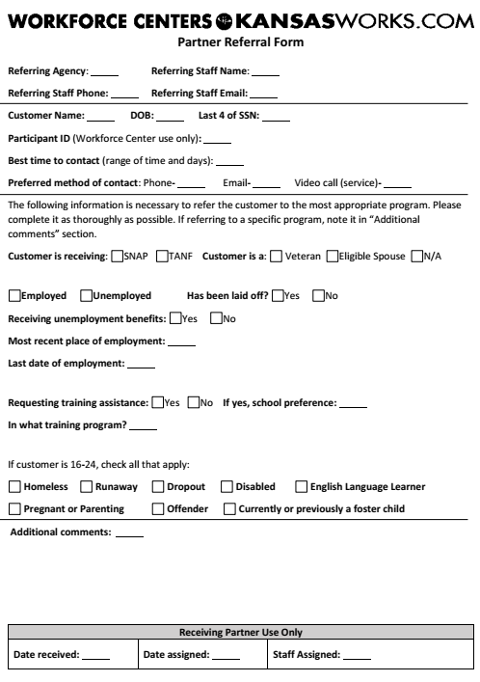

SECTION IV – CUSTOMER RELATIONS

    - Equal Opportunity

Equal Opportunity is the Law
It is against the law for this recipient of federal financial assistance to discriminate on the following basis:
- Against any individual in the United States, on the basis of race, color, national origin including limited English proficiency, age, sex including pregnancy, childbirth and related medical conditions, sex stereotyping, transgender status, and gender identity, political affiliation, belief, religion, disability and;
- Against any beneficiary of programs financially assisted under Title I of the Workforce Innovation and Opportunity Act of 2014 (WIOA), on the basis of the beneficiary's Citizenship/status as a lawfully admitted immigrant authorized to work in the United States, or his or her participation in any WIOA Title I-financially assisted program or activity.
The recipient must not discriminate in any of the following areas:
- Deciding who will be admitted, or have access, to any WIOA Title I-financially assisted program or activity;
- Providing opportunities in, or treating any person with regard to, such a program or activity; or
- Making employment decisions in the administration of, or in connection with, such a program or activity.
The following provisions apply specifically to Employment Service operations conducted by Kansas Works Job Service Offices. States shall:
- Assure that no individual be excluded from participation in, denied the benefits of, subjected to discrimination under, or denied employment in the administration or in connection with any services or activities authorized under the Wagner-Peyser Act in violation of any applicable nondiscrimination law, including laws prohibiting discrimination on the basis of age, race, sex, color, religion, national origin, disability, political affiliation or belief. All complaints alleging discrimination shall be filed and processed according to the procedures in the applicable DOL nondiscrimination regulations.
- Assure that discriminatory job orders will not be accepted, except where the stated requirement is a bona fide occupational qualification (BFOQ).
- Assure that employers' valid affirmative action requests will be accepted and a significant number of qualified applicants from the target group(s) will be included to enable the employer to meet its affirmative action obligations.
- Assure that employment testing programs will comply with all applicable federal regulations.

What to do if you believe you have experienced discrimination
If you think that you have been subjected to discrimination under a WIOA Title I financially assisted program or activity, you may file a complaint within 180 days from the date of the alleged violation with either:
- The recipient's Equal Opportunity Officer, Chad Pettera, Workforce Alliance of South Central Kansas, 2021 N Amidon, Wichita, KS 67203; Telephone: 316-771-6600; Fax: 316-771-6690; TTY: 1-800-766-3777; Email: info@workforce-ks.com; (or the person whom the recipient has designated for this purpose); or Kansas Department of Commerce Regulatory Compliance Director, John Ybarra, at John.Ybarra@ks.gov and 785-296-2122.
- The Director, Civil Rights Center (CRC), U.S. Department of Labor, 200 Constitution Avenue NW, Room N-4123, Washington, DC 20210, 202-693-6502 (voice) 800-877-8339 (TTY/TDD), 202-693-6505 (fax).
If you file your complaint with the recipient, you must wait either until the recipient issues a written notice of Final Action, or until 90 days have passed (whichever is sooner), before filing with the Civil Rights Center (CRC), U.S. Department of Labor, 200 Constitution Avenue NW, Room N-4123, Washington, DC 20210.
If the recipient does not give you a written Notice of Final Action within 90 days of the day on which you filed your complaint, you do not have to wait for the recipient to issue that Notice before filing a complaint with CRC. However, you must file your CRC Complaint within 30 days of the 90-day deadline (in other words, within 120 days after the day on which you filed your complaint with the recipient.)
If the recipient does give you a written Notice of Final Action in your complaint, but you are dissatisfied with the decision or resolution, you may file a complaint with CRC. You must file your CRC complaint within 30 days of the date on which you received the Notice of Final Action.
If you think that you have been subjected to discrimination under the above conditions, you may file a complaint within 360 days from the date of the alleged violation with either:
The recipient's Equal Opportunity Officer, Chad Pettera, Workforce Alliance of South Central Kansas, 2021 N Amidon, Wichita, KS 67203; Telephone: 316-771-6600; Fax: 316-771-6690; TTY: 1-800-766-3777; Email: info@workforce-ks.com; or the Kansas Department of Commerce Regulatory Compliance Director, John Ybarra, at John.Ybarra@ks.gov or 785-2962122; or The Director, Civil Rights Center (CRC), U.S. Department of Labor, 200 Constitution Avenue NW, Room N-4123, Washington, DC 20210, 202-693-6502 (voice) 800-877-8339 (TTY/TDD), 202-693-6505 (fax).
Equal Employment Opportunity Commission (EEOC) Notice on Employer Consideration of Arrest and Conviction History
Title VII of the Civil Rights Act of 1964 makes it unlawful to discriminate in employment based on race, color, national origin, religion, or sex. This law does not prohibit an employer from requiring applicants to provide information about arrests, convictions, or incarceration. But, employers may not treat people with the same criminal records differently because of their race, national, origin, or another protected characteristic. In addition, unless required by federal law or regulation, employers may not automatically bar everyone with an arrest or conviction record from employment. This is because an automatic bar to hiring everyone with a criminal record is likely to unjustifiably limit the employment opportunities of applicants or workers of certain racial or ethnic groups. If an employer’s criminal record exclusion policy or practice has disparate impact on Title VII-protected individuals, it must be job related and consistent with business necessity.
For more information:
http://www.eeoc.gov/laws/guidance/arrest_conviction.cfm;
http://www.eeoc.gov/laws/guidance/qa_arrest_conviction.cfm;
http://www.nationalreentryresourcecenter.org/documents/0000/1082/Reentry_Council_Mythbuster_Employment.pdf
Fair Credit Reporting Act
The Fair Credit Reporting Act (FCRA) requires an employer to obtain the applicant’s permission before asking a background screening company for a criminal history report, and requires the employer to provide the applicant with a copy of the report and a summary of the applicant’s rights before the employer takes an adverse action (such as denying an application for employment) based on information in the criminal history report. For more information:
http://www.ftc.gov/bcp/edu/pubs/consumer/credit/cre36.shtm
For additional information about these notices or to register a formal complaint about a KansasWorks job order or services received in a KansasWorks Workforce Center contact:
John M. Ybarra
Regulatory Compliance Director
Kansas Department of Commerce
1000 S.W. Jackson Street Suite 100
Topeka, KS 66612
(785) 296-2122
Se Habla Español
John.Ybarra@ks.com

    - Grievance and Complaint Policy

Grievance and Complaint Policy
It is the policy of the Workforce Alliance of South Central Kansas (WA) that all workforce programs operated by or under the WA shall be operated in conformance with all applicable laws and regulations. It is also the policy of the WA that no program or provision of services under those programs shall allow discrimination on the basis of race, color, national origin including limited English proficiency, age, sex including pregnancy, childbirth and related medical conditions, sex stereotyping, transgender status, and gender identity, political affiliation, belief, citizenship, religion or disability.

Who May File - Any applicant, participant, service provider, operator, partner or other interested party may file a complaint alleging a violation of local programs, agreements or WA policies and activities.

Complainants with Disabilities - Complainants with disabilities will be accommodated in communication and location. Alternate formats will be used on request to notify the complainant of hearings, results and any other written communication. Auxiliary aides and services, such as deaf interpreters or assistive listening devices, will be provided on request for negotiations, hearings and any other meetings where aural communication occurs. An accessible location will be used for hearings and other meetings on request.

Time and Place for Filing - Complaints may be filed with the WA or the service provider within one year from the date of the event or condition alleged to be a violation. Complaints filed with the WA shall be directed to the following: Chad Pettera, Vice President & COO, Workforce Alliance of South Central Kansas, 2021 N Amidon, Suite 1100, Wichita, KS 67203; Telephone: (316) 771-6600; Fax: (316) 771-6690; TTY: 1-800-766-3777; Email: info@workforce-ks.com.

Resolution Process - Service providers and employers of participants must have procedures in place to process complaints related to the terms and conditions of the participant's training or employment. Employers and service providers may elect to utilize the system established by the WA or operate their own complaint procedures. If the employer is required to use the complaint processing procedures under a covered collective bargaining agreement, then those procedures may be used to handle general complaints.

Any hearings conducted by an employer must comply with all provisions for hearings described in this policy.

Step 1 - Initial Review - If the complaint alleges a violation of any statute, regulation, policy, or program that is not governed by WIOA, the complaint will be referred to the appropriate organization for resolution. Notice of the referral will be sent to the complainant.

The WA or the service provider will receive the complaint from the complainant or the complainant's designated representative. All complaints will be logged. A complaint file should be established that contains the following:
- Application and enrollment forms;
- Completed General WIOA Complaint Form (or complainant's written statement);
- Chronological log of events or conditions alleged to be a violation;
- Any relevant correspondence; and
- Record of the attempted informal resolution.

Step 2 - Informal Resolution - An attempt should be made by the WA or the service provider to informally resolve the complaint to the satisfaction of all parties. The informal resolution process must be completed within ten business days from the date the complaint is filed. If all parties are satisfied, the complaint is considered resolved and the terms and conditions of the resolution must be documented in the complaint file. When a service provider attempts the informal resolution, the service provider will forward the complaint file to the WA. The WA will review the complaint file and investigate it further if necessary.

Step 3 - Formal Resolution - When an informal resolution is not possible, the WA will issue a determination within 20 calendar days from the date the complaint was filed. If an appeal of the determination is not requested, the complaint is considered resolved and the complaint file should be documented accordingly. Any party dissatisfied with the determination may request a hearing within 14 calendar days of the date of the determination.

Step 4 - Hearing - A complaint may be amended or withdrawn at any time prior to a scheduled hearing.

If the complaint is not withdrawn, the WA will request that the Workforce Compliance and Oversight, Kansas Department of Commerce, 1000 S.W. Jackson, Suite 100, Topeka, Kansas 66612 designate a hearing officer to ensure the complaint receives fair and impartial treatment. The hearing must be conducted within 45 calendar days from the date the complaint was filed. The hearing officer will schedule a formal hearing and mail a written notice to the complainant, the respondent, and any other interested party at least seven business days prior to the hearing. The notice will include the date, time and place of the hearing.

Parties may present witnesses and documentary evidence, and question others who present evidence and witnesses. The complainant may request that records and documents be produced. Attorneys or another designated representative may represent each party. All testimony will be taken under oath or affirmation. The hearing will be recorded either in writing or by audiotape. The hearing officer's recommended resolution will include a summary of factual evidence presented during the hearing and the conclusions upon which the recommendation is based.

Step 5 - Final Decision - The WA will review the recommendation of the hearing officer and issue a final decision within 60 calendar days from the date the complaint was filed.

Step 6 - Appeal - Any party dissatisfied with the WA’s final decision, or any party who has not received either a final decision or a resolution within 60 calendar days from the date the complaint was filed, may request an appeal. The appeal must be received by the Kansas Department of Commerce (Commerce) within 90 calendar days from the date the complaint was filed at the following address: Kansas Department of Commerce, Workforce Compliance and Oversight, 1000 S.W. Jackson Street, Suite 100, Topeka, Kansas 66612-1354
Commerce will review the complaint file, the hearing record, and all applicable documents and issue a final decision on the appeal within 30 calendar days from the date the appeal was received.

    - Reporting Suspected Program Fraud or Abuse

Workforce Centers’ partners are required to report suspected fraud or abuse of any kind timely to either the Local Workforce Development Board Chair, Kansas Department of Commerce, or United States Office of Inspector General. Suspected fraud can include misapplication of funds, gross mismanagement, or abuse of authority. Fraud can be, but not limited to, bribery, forgery, extortion, embezzlement, theft, kickbacks, misuse of funds, misrepresentation of information.

Individuals are protected by Whistleblower’s Act (Kansas Statue No. 75-2973) and Whistleblowers posters are posted along with other legally required employment notices in all the Workforce Centers to provide guidance.

Individuals can provide a written report of suspected fraud or abuse on their own form, or can use the fraud or abuse reporting form found in Kansas Department of Commerce Workforce Services Policy #5-11-00 that can be found at www.kansasworksstateboard.org/PoliciesandProcedures. Policy #5-11-00 also provides information on the types of fraud and contains information that might help and individual make a determination of the suspected fraud or abuse. If in doubt of the possibility of fraud or abuse, and individual is required to file a report. Contact information for the Local Board Chair can be found under the board section of www.workforce-ks.com. Reports to the Kansas Department of Commerce can be filed with:

John Ybarra
Kansas Department of Commerce
Director of Regulatory Compliance
1000 SW Jackson St, Suite 100
Topeka, KS 66612-1354
785-296-2122
(fax) 785-296-3612
John.Ybarra@ks.gov

Individuals can also report suspected fraud or abuse directly to the United States Office of the Inspector General (OIG/USDOL) at 1- 800-347-3756.

    - Limited English Proficiency

Limited English Proficiency Definition
Individuals who do not speak English as their primary language and who have a limited ability to read, write, speak, or understand English can be limited English proficient (LEP) and be entitled to language assistance with respect to a particular type of service, benefit, or encounter. LEP individuals may be competent in English for certain types of communication (e.g. speaking or understanding), but be LEP for other purposes (e.g. reading or writing).

Identification of LEP Persons
Census data indicates that Spanish and Vietnamese are the languages most often used in Local Area IV by persons with LEP.

If a person's primary language is not recognized by staff, the Language Identification Flashcard will be used to identify the language. The Language Identification Flashcard is included below. The Language Identification Flashcard shall be maintained and easily accessible at all Workforce Center entry points.

Language Assistance Services and Interpretation
Any language assistance services, whether oral interpretation or written translation must be accurate, provided in a timely manner and free of charge to the LEP individual. Language assistance will be considered timely when it is provided at a place and time that ensures equal access and avoids the delay or denial of any aid, benefit, service, or training.

Staff shall use Language Line services for all interpretation services. Instructions on how to access and use the Language Line are available on the Workforce Centers Intranet. Staff, even bilingual staff, shall not provide interpretation services for LEP individuals. Bilingual staff may interpret or facilitate communication in emergency situations while waiting for a qualified interpreter.

Staff shall not require a LEP individual to provide their own interpreter. Additionally, staff shall not rely on a LEP individual’s minor child or adult family or friend(s) to interpret or facilitate communication. A LEP individual’s minor child or adult family or friend(s) may interpret or facilitate communication in emergency situations while waiting for a qualified interpreter.

SECTION V – CONTINUOUS IMPROVEMENT

The Workforce Alliance is committed to regular review of service delivery practices to ensure an ongoing focus on continuous improvement within the Workforce Centers of Local Area IV. Input from customers, internal partners, and community partners is critical to the progression of delivering a high level of customer service while aiming to meet needs of area businesses by connecting employers with a skilled workforce.

- Core Values of Performance Excellence

Workforce Center partners are committed to creating a system-wide focus on performance excellence through continuous improvement.

At the heart of any successful continuous process improvement initiative is involvement of every employee at every level of the organization. As the Workforce Centers’ continuous improvement strategies evolve, employees are invited to serve on work groups and to apply principles of improvement in the course of performing day-to-day activities.

Below are the eleven (11) core values for performance excellence identified for the Workforce Centers:

- Customer Driven Excellence
- Visionary Leadership
- Valuing Employees and Partners
- Organizational and Personal Learning
- Focus on the Future
- Systems Perspective
- Agility
- Management by Fact
- Managing for Innovation
- Public Responsibility and Citizenship
- Focus on Results and Creating Value

- Customer Service

It is imperative that all customers of the Workforce Centers be treated with courtesy and respect. If you encounter a difficult customer, do not take it personally; maintain your professionalism. Please be mindful of the people you come in contact with on a daily basis; your actions, words, and expressions may be putting off a signal that you are not truly interested in assisting a customer. Please remember the “10 Best Ways to Show Your Commitment to Excellence”:

- Provide prompt service. Answer phones quickly or, if face-to-face, acknowledge customers right away.
- Stay upbeat and friendly. Keep a smile on your face and in your voice.
- Give customers and their needs your undivided attention.
- Be accurate and organized. Have information at your fingertips and take notes.
- Communicate clearly. Talk in plain language, not jargon, and speak slowly.
- Show courtesy and respect, even if a customer is upset.
- Keep up to date on products, services, procedures, and policies.
- Provide solutions. If you are unable to fulfill a customer’s request, offer options.
- Keep your word. Build trust and customer loyalty by doing what you say you are going to do.
- Always ask what else you can do for your customer.

Local Area IV Workforce Centers Customer Service Bill of Rights

We commit together that each job-seeker, employer, partner, and co-worker who calls, visits, uses, or works in our Center is entitled to treatment in the following manner:

Satisfying Customers with Our Services: Because our customers are turning to us to meet some need, we will suggest services, programs, and products the customers can use but may not know about or have thought of to meet those needs. There is always more than one way to meet the customers’ needs, and we will be flexible in how we accomplish it.

Treating Customers Courteously: We will consistently treat employers and job-seekers alike with respect and dignity. We will strive to go beyond the Golden Rule, treating them as we want to be treated, to the “Platinum Rule:” Treating our customers as they want to be treated. We communicate clearly to the customers, at their level, without using acronyms, buzzwords, or other language they don’t understand or that would make them feel uncomfortable.

Prompt, Friendly Service: We will acknowledge the customers who come in, put them at ease, and respect their time, which is as important to them as ours is to us. We will therefore treat their time as our own. We will make them comfortable and welcome.

Closing Each Customer Interaction: As our customers finish their business with us, we try to make sure each employer and job-seeker feel that they are valued parts of the Workforce Center.

Polite Understanding of the Customer’s Situation: We will take the time to understand the customer’s situation and address it without argument. We will listen both with attention and generosity so that we forgive customer behaviors displayed out of frustration, fear, panic, or other emotions. Understanding that although we deal with customers in their situations every day, this is a stressful situation for them, we are non-confrontational. This allows us to learn the customer’s true needs, even when the customer him- or herself may not know that those needs are.

Get it Right or Make it Right: We will focus on accurate, reliable, quality service to employers and job-seekers. This is critical to our credibility. We take this as a matter of honor. When occasions happen that we realize we have made an error, we make the situation right for the customers. We realize that while a problem may be a minor annoyance to us, or no big deal, it may well be the most important thing in a customer’s life when it happens. Regardless, we acknowledge that it deserves immediate attention. We do not dwell on fault, nor do we minimize the customer’s experience of the problem. Instead, we seek solutions that will both eliminate the cause of the customer’s stress and prevent future customers from experiencing the same problem.

Open Professionalism in Delivering Our Services: Each of us know our jobs, and focus on work- and job-related activities at work. We treat each other, our job-seekers, and our employers, with dignity and respect at all times. When we see things that need to be done—we simply do them without concern for whether or not it’s “our job.” We will each be ready to help job-seekers and employers with high-quality, value-added services. We constantly update our knowledge of the services, products, and programs offered through Local Area IV Workforce Centers so we can better serve our customers. Knowing that customers hold us to promises made through Workforce Center we each commit to knowing the services offered through our center, and how to provide them.

Customer-Focus and Follow-Through: We will help meet job-seekers’, employers’, partners’, and coworkers’ needs in a way that the customers feel that they are the Center’s priority while we are in contact with them. We apply the principles and practices of customer service. We are accountable not only to our customers but to each other. We welcome the help and feedback of our colleagues and peers in achieving our goals of superior customer service.

Introduce Customers to the Person Who Can Help: We may not always be the right person to meet a customer’s needs. When someone else can better help them, we will directly and personally introduce the customer to that person, when possible. We will “hand them off, not pass them off.”

Happy Workforce Center Employees: Our customers have a right to be served by employees who enjoy the work we do and believe that the services, programs, and products we provide are important. We each will find those things we can enjoy in our job, and let that influence our attitude to our customers.

Our Belief in Pleasant Surprises: When we undertake the activities above, we believe our customers will encounter pleasant surprises when they work with us. These surprises will keep our customers internal or external satisfied and confident in the services that they received from the Workforce Center staff.

Local Area IV Customer Service Grid

JOB AID FOR DESCRIBING BEHAVIORS FOR ELEMENTS OF CUSTOMER SERVICES
WICHITA WORKFORCE CENTER
Customer Service Element | Examples of Behaviors |  |  | Your Rating: |  |  | Your Rationale
 | Unacceptable 1 | Acceptable 2 | Exceptional 3 | 1 | 2 | 3
Customer Satisfaction—suggest services, programs, and products the customer can use to meet their needs; flexibility in approach | Tells the customer that “that’s not our problem”  Tells the customer “I used what you gave me, so it’s not my fault”  Does not assist customers, whether employers or job-seekers  Takes customers literally instead of listening for deeper customer needs  Tells the customer that the way Kansas 1st offers the service is the only way it can be received | Greets job-seekers and employers promptly and cheerfully, despite whatever else is going on  Asks customers questions that identify their needs  Helps customers see how Kansas 1st services help with their needs  Apologizes for customers’ problems, and reassures that we can help  Tells the customer “Let’s see how I can help”  Sees to it that each employer or job-seeker is placed into contact with the right person to assist | Takes initiative to tailor services within ethical, moral, and legal boundaries  Finds errors up front, and takes the initiative to fix them without a customer complaint  Finds or creates services specific to the customer’s unique needs  Go above and beyond to serve the customer by asking if there is anything else you can do for them and giving them your contact information for future use
JOB AID FOR DESCRIBING BEHAVIORS FOR ELEMENTS OF CUSTOMER SERVICES
WICHITA WORKFORCE CENTER (Continued)
Customer Service Element | Examples of Behaviors |  |  | Your Rating: |  |  | Your Rationale
 | Unacceptable 1 | Acceptable 2 | Exceptional 3 | 1 | 2 | 3
Maintains a Courteous Workplace—ensures that professionalism rules the day, addresses conflicts directly but respectfully, directly and personally introduce a customer who needs help from someone else to that person | Swears anyplace in the workplace  Ignores customers if it doesn’t seem the employee has the ability to help them  Cuts customers off when they are speaking  Uses body language that communicates to the customer “you bother me”  Tells the customer who to go to for help  Points to or yells across the room at the person the customer needs for help | Treats customers with dignity and respect  Listens patiently to customers  Is approachable  Makes a best effort to help the customer before handing off to someone else  Explains who can best help the customer and why  Escorts the customer directly to the person who can best help  Informs the person who can best help the customer, if busy, and then tells the customer how long a wait to expect  Understands that the customers who have the greatest need likely have the most difficult time knowing their own needs | Takes the extra step to be sure customers feel comfortable, even in uncomfortable situations  Follows up with customer to be sure the help was appropriate  Gives customer own name and contact information and promises to help with other questions or needs  Before referring customer to another individual, learns all customer needs and helps with all those things that can be helped with first

JOB AID FOR DESCRIBING BEHAVIORS FOR ELEMENTS OF CUSTOMER SERVICES
WICHITA WORKFORCE CENTER (Continued)
Customer Service Element | Examples of Behaviors |  |  | Your Rating: |  |  | Your Rationale
 | Unacceptable 1 | Acceptable 2 | Exceptional 3 | 1 | 2 | 3
Prompt, Friendly Service—Acknowledge the customers who come in, put them at ease, respect their time | Uses a rude or insincere tone of voice when greeting job-seekers or employers  Makes customers ask for assistance before offering any  Frowns when greeting customers  Makes customers wait even when the Center isn’t busy  Takes breaks instead of assisting waiting customers  Assumes customers have computer skills and/or know Kansas JobLink  Returns phone calls later than next business day  Takes more than 1 business day to post an employers’ job order | Smiles when greeting customers  Greets customers with a phrase such as “I’ll be with you in a moment” or “How may I help you?”  Returns phone calls by close-of-business  Places job orders the same day they are received  Answers phone by the third ring  Smiles when answering the phone | Acknowledges customers within 10 seconds of the customer walking in  Asks someone else to help a customer who must wait  Recognizes return customers and greets them by name  Apologizes for waits  Posts job orders within 2 hours  Answers the phone after the first ring  Returns calls within one hour
JOB AID FOR DESCRIBING BEHAVIORS FOR ELEMENTS OF CUSTOMER SERVICES
WICHITA WORKFORCE CENTER (Continued)
Customer Service Element | Examples of Behaviors |  |  | Your Rating: |  |  | Your Rationale
 | Unacceptable 1 | Acceptable 2 | Exceptional 3 | 1 | 2 | 3
Closes Customer Interactions—Make employers and job-seekers feel that they are valued parts of the Workforce Center | Fail to acknowledge them as they leave  Acknowledges them with an insincere tone of voice  Calls out “thank you” over the shoulder instead of taking the time to sincerely thank the customer  Allow them to walk out the door  Fails to check with customers to see if they have more needs | Says “Thank you for using the Workforce Center today”  Invites the customer to return  Asks if the Workforce Center can serve any family or friends of the customer  Tells the customer to have a great day  Refers customer to at least one additional service for which he or she is qualified  Gives the customer a call-back number or e-mail and says “please let me know how this turns out for you”  Greet the customer by name and says something like “Great to see you” | Adds value to the customer’s experience by explaining upcoming events such as workshops that may be of interest  Asks the customer what other needs the contributor can help with  Refers the customer to additional services for which he or she is suitable  Solicits customer feedback on how well the Center met his or her needs  Provide follow up assistance as appropriate with customers
JOB AID FOR DESCRIBING BEHAVIORS FOR ELEMENTS OF CUSTOMER SERVICES
WICHITA WORKFORCE CENTER (Continued)
Customer Service Element | Examples of Behaviors |  |  | Your Rating: |  |  | Your Rationale
 | Unacceptable 1 | Acceptable 2 | Exceptional 3 | 1 | 2 | 3
Polite Understanding—take the time to understand the customer’s situation and address it | Says things like “We can’t help you,” “We don’t do that here,” or “What do you want?”  Makes rude comments to or about customers or co-workers | Asks questions that will help understand what the customer needs  Matches customers’ needs to services  Says “Here’s what we can do” when a customer makes a request that can’t be met  Meets the customers “where they are” without judgment or prejudice | Gives customers the information they need, even if the contributor has to find it  Shows patience and doesn’t rush customers  Makes the customer feel as if they’re the most important person in the Center right now
Get it Right Or Make it Right—Focus on accurate, reliable, quality service to employers and job-seekers | Fails to provide information customers need  Provides customers with incorrect information  Passes the buck when told information was inaccurate  Blames customers for not knowing what they need | Gives customers an answer that limits them to a single option  Provides customers with the right information in timely fashion  Ensures that information going to customers is up-to-date  Responds quickly to customer problems  Refers errors to the appropriate person  Accurate information is organized and accessible | Gives customers answers that allows them to have multiple options  Follows up with customers to ensure that the information was what they needed  Anticipates customers’ needs and has the correct information ready for them  Recognizes when information is inaccurate, and takes initiative to correct it
JOB AID FOR DESCRIBING BEHAVIORS FOR ELEMENTS OF CUSTOMER SERVICES
WICHITA WORKFORCE CENTER (Continued)
Customer Service Element | Examples of Behaviors |  |  | Your Rating: |  |  | Your Rationale
 | Unacceptable 1 | Acceptable 2 | Exceptional 3 | 1 | 2 | 3
Open Professionalism in Delivering Our Services—Know your job and focus on work- and job-related activities at work | Does not know basics of job or Workforce Center information  Fails to learn job basics or Center information  Finishes non-business activities before assisting customers  Rolls eyes, sighs, or otherwise makes customers feel like they are a bother  Tells a customer “We don’t do that/ we can’t help you here.”  Does not provide a service, program, or product advertised or promised  Bluffs the customer when an answer to a question is unknown | Respects job-seeker and/or employer confidentiality  Gives attention to customers rather than starting them on a project and then leaving them  Follows up to help customers with new questions or problems  Follows the dress code  Helps with basic customer questions or needs on all job-seeker and employer programs and services  Keeps up-to-date on offered programs and services  Tells the customer “I don’t know—let’s find out together”  Makes referrals to coworkers or partners | Treats customers better than expected  Controls own emotions when customers lose control of theirs  Takes/ creates opportunities to deescalate customer confrontations  Focuses on the situation, not the person  Treats coworkers with the utmost respect  Seeks information on which customers are likely to come in, anticipates their likely needs, and has materials and services ready for them  Refers customers to resources outside the Workforce Center and Partner network, even when they are outside the scope and mission of the Center

JOB AID FOR DESCRIBING BEHAVIORS FOR ELEMENTS OF CUSTOMER SERVICES
WICHITA WORKFORCE CENTER (Continued)
Customer Service Element | Examples of Behaviors |  |  | Your Rating: |  |  | Your Rationale
 | Unacceptable 1 | Acceptable 2 | Exceptional 3 | 1 | 2 | 3
Customer-Focus and Follow-Through—Help meet costumers needs in a way that they feel that they are the Center's priority while in contact with them | Makes people wait while finishing personal business or having conversations with other employees  Interrupts customers, finishes their sentences, or otherwise does not listen to them  Tells customers “That’s not part of my job” | Asks customers questions that identify their needs  Helps customers identify and solve their problems  Goes to the customers to greet them | Listens with empathy to understand both the customer’s experience and the customer’s need  Offers the customer solutions with many options  Goes above and beyond the job description to help customers
Introduce Customers to the Person Who Can Help—directly and personally introduce a customer who needs help from someone else to that person | Ignores customers if it doesn’t seem the employee has the ability to help them  Tells the customer who to go to for help  Points to or yells across the room at the person the customer needs for help | Makes a best effort to help the customer before handing off to someone else  Explains who can best help the customer and why  Escorts the customer directly to the person who can best help  Informs the person who can best help the customer, if busy, and then tells the customer how long a wait to expect | Follows up with customer to be sure the help was appropriate  Gives customer own name and contact information and promises to help with other questions or needs  Before referring customer to another individual, learns customer needs and/or barriers. Assist and refer to resolve identified needs and barriers

JOB AID FOR DESCRIBING BEHAVIORS FOR ELEMENTS OF CUSTOMER SERVICES
WICHITA WORKFORCE CENTER (Continued)
Customer Service Element | Examples of Behaviors |  |  | Your Rating: |  |  | Your Rationale
 | Needs Development 1 | Effective 2 | Highly Effective 3 | 1 | 2 | 3
Happy Workforce Center Employees—enjoy the work and believe the services, programs, and products are important | Lets “bad days” affect service to job-seekers or employers  Mumbles so that customers cannot hear or understand  Uses body language such as frowns or lack of eye contact that communicate dissatisfaction to customers  Moves lethargically in response to customers | Makes eye contact with and smiles at customers  Welcomes each job-seeker or employer the contributor comes into contact with  Makes an effort to be helpful to any customer who asks or appears to need assistance  Maintains a cheerful disposition | Responds enthusiastically and energetically to customer requests  Maintains an upbeat attitude, regardless of what else may be going on  Projects goodwill to all customers and coworkers  Demonstrates a “sparkle” and sense of appropriate fun  Embraces change

